**HOME PAGE:  The Menu bar will be opaque and tranparen as we scroll down**

DSW Home Solutions Products Services Training About Us Request a Demo <Social media buttons and site search>

**Accelerate the Next.**

Build with hybrid open source, data science   
and Artificial Intelligence, ethically applied.

Want to know more?

**Headline on the banner can be - Unlock the power of AI -**

**sub heading needs to be finalized - please add a place holder for same**

**Everyone can go AI.**

As the applications of Artificial Intelligence gain momentum in everyday life,   
we aim to nurture its ecosystem with data-driven, open-source technology solutions   
and training that benefit businesses, customers, communities and stakeholders.   
We are building the world of tomorrow.   
We are accelerating the next wave of change. For everyone.

**>**

**The robust man-machine advantage.**

We believe in blending man and machine learning into a hybrid system   
that is smarter, intuitive and driven by stronger ethical considerations.

All our open source AI solutions are robust, value driven,  
 industry agnostic and focused on accelerating positive change.

**Ethical Value oriented**

**Robust Models**

**Agnostic solutions**

Optimised solutions designed to be ethical and cost-effective across initial build and operational costs for greater goodwill and LTV.

Reliability is built in from the start with robust modeling and testing architecture to ensure successful outcomes.

Assistance in migration from expensive legacy lock-ins to solutions that are more flexible and tuned to evolving business needs.

**Domain expertise**

**Training / Up-skilling**

**Responsiveness**

With a combined experience of over 100 years across our team, we offer open source AI domain expertise for BFSI, Insurance and other verticals.

Modular training of new hires or upskilling of existing talent can save costs in the digital transformation process.

Based on areas of engagement, a 24x7 service, consultancy and trouble-shooting support is available.

The details should go as place holder, and not hover.( Can evaluate both options)

**Intelligence in Action.**

Artificial Intelligence is helping businesses to read between the lines   
and create strategies that are based on data metrics rather than gut-feel.   
See how this is translating into personalised experiences for customers,   
smoother processes and enhanced security of operations.

**Insurance** | **Banking** | **Telecom** | **Health** | (hidden for now -- just show Insurance) - This will be dynamic to add more sectors when needed in future

**InsureAI Use Case ( Element Ref: <https://arya.ai/> Refer below for Element Design )**

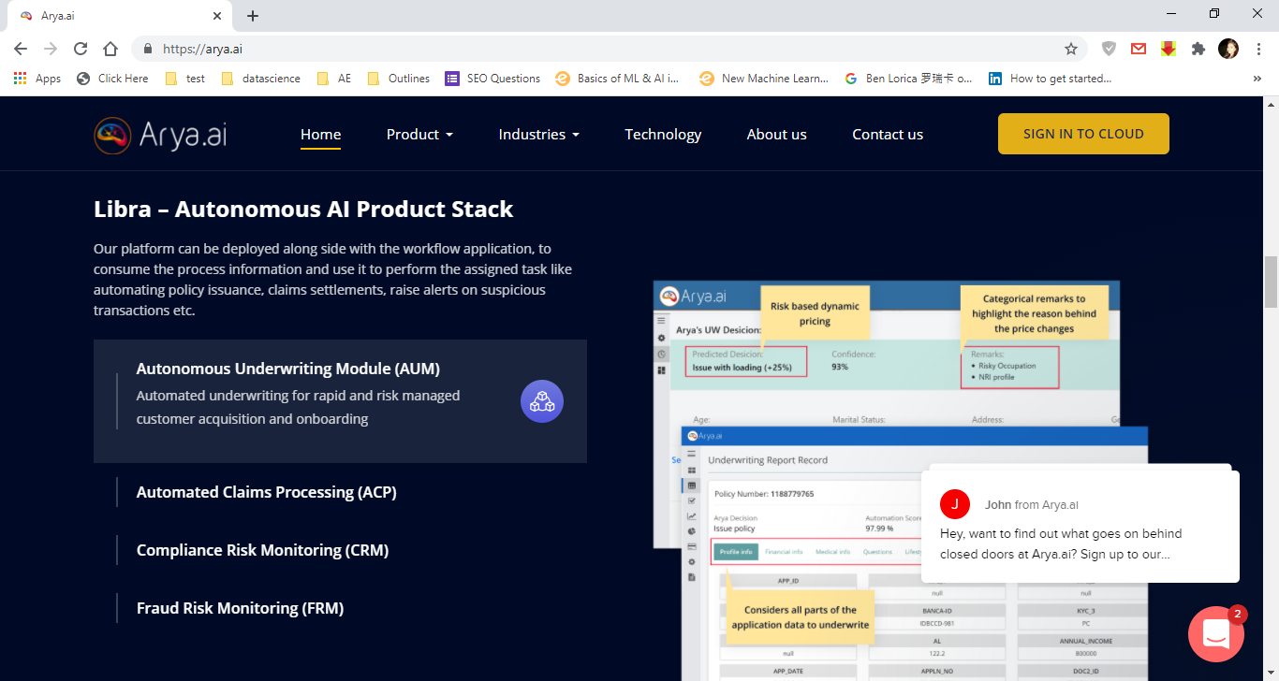

**Fraud Mitigation - Change to Fraud Prevention**

InsureAI is ideal in filtering and correlating large volumes of data to look for the unusual or suspicious. As data volumes grow beyond the capability of manual checks and intervention, InsureAI offers a risk mitigation capability by analyzing the data streaming from known and unknown sources to flag suspect claims, transactions, document submissions or patterns of behaviour for immediate action.

**Product development**

With access to more data points, InsureAI can better read customer attitudes and behaviour, resulting in quicker identification of insights, trends and segments, for the development of new products with customisations in price and features.

**Streamlined Processing- Change to Streamlined Onboarding**

Insurance application and underwriting processes can get far faster with InsureAI. Algorithms can verify KYC details, check risk profiles and behaviour to match premium norms, verify payments and speed up application process times.

**Risk scoring**

Aggregated data, credit and risk scores can be more efficiently analysed by InsureAI to create better underwriting models that speed up the insurance approvals and lower cost of acquisition.

**Market identification**

Simply having a desirable product is no longer enough. Knowing how to market and sell the product to the right customer at the right time is equally important. InsureAI assists in analysing and devising the ideal marketing strategy to ensure significant market penetration and customer receptivity.

**Customer Satisfaction**

Customer experience can be a key factor in brand goodwill, customer retention and repeat business. Understanding customer queries and grievances, and creating fast and easy resolution processes generates positive customer opinion. InsureAI employs NLP and AI assisted chat-bots to ensure customer satisfaction.

**Compliance**

Manual checking of KYC forms and claims can result in saturation backlog and affect claims settlement indices. InsureAI helps in streamlining business processes and fast-tracking claims settlement by performing  document and forms analysis.

Form

**Transform Your Business with AI**

Submit this form if you would like us   
to help you Accelerate the Next.

Full Name:

Email:

Mobile Number:

Country:

Select Your Query: Dropdown to select our offerings

Message

Submit

Sticky menu expansion

**Solutions(dynamic) Services(dynamic)Products(dynamic) Trainings(dynamic)**

|  |  |  |  |  |
| --- | --- | --- | --- | --- |
| **By Industry**  - Insurance - InsureAI  - Underwriting and Risk Rating  - Fraud Mitigation  - Marketing and Sales  - Claims Management  - Customer Servicing  - Product Development  - Operational Efficiency | **By Use Case**  - Intelligent Log Management & Monitoring  - DevOps Maturity Workbench  - INTELLICI/CD | - Helping customers in identifying & discovering relevant AI trends, use-case specific to their sector & business.  -Helping in determining AI ROI Impact  - Helping customers to develop AI strategies and initiatives  -Discovery and Analysis - analysis and assessment of the data, including key trends, high-ROI opportunities, and specific next-step recommendations ranging from the ROI of AI, AI deployment, team and talent dynamics  - 1:1 Access to our Data Scientist | - Aadhaar Masking  - Video Consent  - OCR for KYC Docs  - Face Recognition  - Smart Form  - Chatbot  - Call Center Analytics | - Data Science Foundations with Python and R  - Python for Data Science  - R for Data Science  - Machine Learning  - AI and Deep Learning  - Complete Data Science Program  - More courses |

**Tentative flow of pages and details:**

Home page- As given in the layout:

<https://damp-frog-6004.animaapp.io/?r=1&p=yeOtbiG&s=web-1920-3>

**Below are the font and colors details for Home :**

Font family --- Open Sans (Google Font)  
Orange shade --- #FF5D2E  
Dark Blue shade --- #000926  
Gray shade --- #F8F8F8

----------------------------------------------------  
Transparent orange shade element  
#FFAC40DE  
#FF660099

Solutions Page -- Platforms By Sector and By Use Case. This page will list all the platforms sector wise and general platforms. Each Use case will then have a separate page. ( Refer <https://www.h2o.ai/>)

Products Page -- Listing all DSW Products and separate pages for each.

Services Page - Listing all services

Training Page- Listing all courses and training- Each course will then have separate page, the template would be similar

About Us- This page will have all details about the vision mission, our team, advisors, mentors and so on.

Resources - Blogs, Announcements and so on.